Development of Bhojpuri WordNet
Kamal Kumar Gupta1, Ismail alam¹,
Akshay Deepak1, Anurag Kumar1

¹Computer Science Department, National Institute of Technology Patna
{kamal.cspg15, ismail135001, akshayd, anurag135012}@nitp.ac.in

Abstract. WordNet is used as a knowledge resource of lexical and ontological structure of a language. Many applications of natural language processing like machine translation, word sense disambiguation, information retrieval etc. use WordNet as a knowledge base. This paper presents the development experience of Bhojpuri WordNet. Bhojpuri is the language spoken in many regions of eastern India. Formation of synsets and different types of relationships among synsets is also illustrated. Bhojpuri WordNet has been hosted as a publicly accessible website where web users can browse words and also suggest modification/addition to existing Bhojpuri WordNet.
Keywords: WordNet, Bhojpuri WordNet, semantic relation, lexical relations
1 Introduction
In natural language processing WordNet[7] is a very popular machine readable dictionary. It was first developed for English language at Princeton University in 1985 [7]. WordNet consists of synsets and their lexical information. A synset is a group of synonym words, i.e., collection of words having same sense in a particular context. A word can have multiple senses on the basis of its use, i.e., in the context of the sentence in which it is used. A word can be part of more than one synset and can be of different POS (part of speech). It links different words from noun, verb, adjective and adverb to form synsets of different meanings. For example [पले, दरिए, पँजरा, भीरी] are synonyms and forming a synset that means निकट​( Near ). Likewise अरज word has two different meaning in Bhojpuri; one is (प्रार्थना, आग्रह) ‘Request’ and second is (कपड़ॆ, खेत आदि की चौड़ाई) ‘Width’. WordNet provides the meaning, example and ontological texture of the synsets by defining semantic relationships among them. Various relations are defined in WordNet like hypernym, hyponym, holonym, meronym, entailment, troponym etc. between language concepts. Some of the prominent applications of WordNet are in the field of query expansion[11], word sense disambiguation[1], text classification[9], machine translation[5] etc. The Bhojpuri WordNet links the lexical information of Bhojpuri language with the help of similarity of their meanings and semantic relationships. In Aryan languages of India Bhojpuri is an important language of Hindi family. ‘Kaithi’ and ‘Devnagari’ are two scripts in which Bhojpuri is written. In eastern Uttar Pradesh, Bihar, some part of Jharkhand and Nepal, Bhojpuri language is widely spoken. It is also one of the recognized national languages of Nepal and has official status in Fiji as Fiji Hindi. It is also a recognized language in Guyana, Suriname, and Mauritius.
The organization of the rest of the paper is as follows: Section 2 describes the related work of WordNet that happened previously. Section 3 defines various relationships that are used among synsets. Section 4 has information about synset creation, database used, semantic relations, web interface of Bhojpuri WordNet. Section 5 tells the work that is to be completed further. Section 6 concludes the work.
2 Related Work
Princeton WordNet[3] is the pioneer in area of WordNet. It was developed in Cognitive Science laboratory in Princeton University starting in 1985. This WordNet was built to represent the synsets of English language. Popularity and success of this project inspired researchers to work on WordNet of other broadly spoken languages like European, Chinese, Hindi etc.
Indo WordNet[10] is a knowledge base which binds the WordNet of some Indian languages (Hindi, Sanskrit, Tamil, Bengali) together. In this Hindi WordNet was the first WordNet made for an Indian language. EuroWordNet[12] was developed to link the WordNets of several European languages (Spanish, Italian, Dutch).Chinese WordNet[4], PL WordNet[6] etc. these are some other WordNets for their respected languages. Developing WordNet of various languages is useful for extending the limits of research in linguistics and natural language processing field for the purpose like machine translation and multilingual database etc. SentiWordNet[2] is an extended application of WordNet which assigns score to the synsets and determine the sentiment of term (positive, negative, neutral). This SentiWordNet is used for sentiment analysis to form an opinion regarding the reviews, tweets and many more text statements.
3 Semantic Relations in WordNet
There are different kind of semantic relations are defined between synsets and words.
3.1 Antonym
Antonym is a relation that indicates opposite nature of word forms. For example “भइया” BHAIYA (brother) is having 'antonym' relation with “बहिनी” BAHINI (sister).
3.2 Hyponym/Hypernym
Hyponym is a semantic relation among word meanings. It is an ‘ISA’ or ‘subset/superset' relation between synsets. For example “भुभुनाठ” BHUBHUNAATHA (nostril) is 'hyponym' of “अलंग”ALANAG (body part). It means “भुभुनाठ” BHUBHUNAATHA (nostril) is a kind of “अलंग”ALANAG (body part). Its inverse is hypernym. So that “अलंग” ALANAG (body part) is 'hypernym' of “भुभुनाठ” BHUBHUNAATHA (nostril). This relation is transitive in nature.
3.3 Troponym
This is semantic relation between verbs. Troponym relation is same as hyponym relation is for noun synsets. For example "मुस्काइल” MUSKAIL (smile) is a kind of "हंसल"​ HANSAL (laugh) and these are verb so we can say "मुस्काइल" MUSKAIL (smile) is 'troponym' of "हंसल"​ HANSAL (laugh).
3.4 Meronym/Holonym
These semantic relations are a 'part-whole' relation. Meronym relation between two synsets represents that one synset is a part of other synset. For example "पांख​" PAANKHA (feather) is 'meronym' of "चिरई" CHIRAI (bird). It means "पांख​" PAANKHA (feather) is part of "चिरई" CHIRAI (bird). Holonym is inverse of it that indicates the 'whole' side in relation. "चिरई" CHIRAI (bird) is 'holonym' of "पांख​" PAANKHA (feather).
3.5 Entailment
This relation is between verbs. Entailment is an implication, that is, a verb B that follows logically from or is implied by verb A. So we'll say A entails B. For example "सिसुकल​" SISUKAL (sob) entails "रोअल​" ROAL (weep). But inverse is not true. Entailment is a unidirectional relationship.
3.6 Ability verb
This noun-verb relationship shows the inherited trait of someone or something. For example "रोअल​" ROAL (weeping) is 'ability' of "मनई" MANAI (man).
3.7 Capability verb
This noun-verb relationship shows the acquired trait of someone or something. For example "अलापल​" ALAAPAL (singing) is 'capability' of "मनई" MANAI (man).
4 Process of creating Bhojpuri WordNet
Development phase of Bhojpuri WordNet has various works to do like synset creation, database management, establishing semantic relations, RDF creation and web interface. For Bhojpuri words with their POS and meaning we took the help of BHOJPURI-HINDI-ENGLISH dictionary published by ‘Kendriya Hindi Sansthan’.
4.1 Synset creation
For creating synsets for Bhojpuri WordNet we used expansion approach. We used Hindi synsets of Hindi WordNet developed by IIT Bombay. It means we created synsets for Bhojpuri WordNet by adding new words to a Hindi synset or deleting extraneous words synset that are not from Bhojpuri language. In Figure 1 we can see the tool that we are using. It fetches the Hindi synsets from text file one by one and is converted to Bhojpuri synsets with their Bhojpuri example as shown in Figure 2. POS and concept part will remain unchanged. After all synset creation for making semantic relations among synsets one separate java code is written that is discussed further. For example-
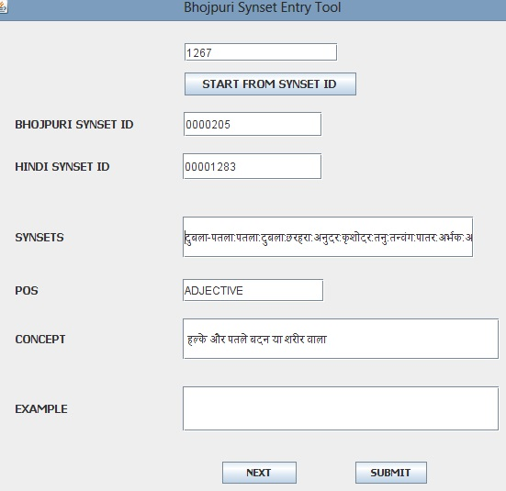

Figure 1. Hindi synset from text file

A Hindi synset is {मुख्य_द्वार:मुख्यद्वार:मुख्य_दरवाज़ा 'main door' } with concept - "किसी भवन, घेरे आदि का सबसे प्रमुख या बाहरी द्वार", example - "यह इस किले का मुख्य द्वार है ।" and POS is “noun”. Now Bhojpuri Synset after adding new Bhojpuri words and deleting some words will be {साह दरवाजा:पइसार:निकसार 'main door'} preserving same sense and POS with example - "घर के साह दरवाजा होने बा ।"
This approach is helpful when we are converting Hindi synsets into Bhojpuri Synsets. However, there are so many new words in Bhojpuri language which were not matching with any synset of Hindi WordNet. So for this we have to manually insert the details of new senses in database. So for constructing Bhojpuri synsets by using Hindi synsets we developed a small java based tool that fetch the Hindi synset details from text file of Hindi synsets and then one can add the Bhojpuri words and example by keeping the sense of synset unchanged. These synset details directly store in various tables in their suitable columns. The database details are discussed in next section.

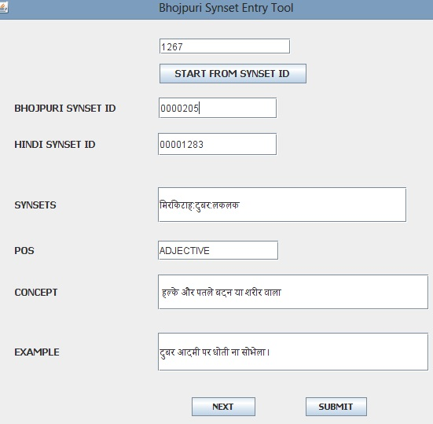

Figure 2. Equivalent Bhojpuri synset with example

4.2 Database Structure

Here we are using relation database for storing our WordNet data. Tables are created in MySql database. In table 1 the description of database[8] is given. synset_word is used to store words in the synsets. Words having same synset id will be considered as member of same synset or synonyms. Likewise same word having multiple synset ids will be polysemous i.e. word having different senses. synset_concept_example table holds the respective concept and example for synset ids of the desired word. Third table relation_type gives the details of what kind of relationships a particular synset holds with other synsets. semantic_rel table holds the synset ids of the other synsets and also the relationship type by which these synsets are linked with target synset.
4.3 Establishing Semantic Relations
Here for defining semantic relationships we are using only two tables described in Table 1 named as

Table 1. Database for Bhojpuri WordNet

 | Table name | Column Name | Description
1 | synset_words | Synset id, Word | Stores words
2 | synset_concept_example | Synset id, Concept,  Example, POS | Stores Concept,  example and POS
3 | relation_type | Synset id, relation id | Relationships a  synset holds
4 | semantic_rel | Synset id, Parent id, Child id | Relationship details

'relation_type' and 'semantic_rel'. 'relation type' holds the details of all relation ids (e.g. hypernym, meronym, entailment etc.) that a single synset holds (because a synset can have multiple semantic relationships with other synsets). 'semantic rel' table contains the details of both synsets which are linked to each other with a particular semantic relation. Table relation_type has the field synset_id and relation_id, this field tells about what kind of relation a synsets has, because it is possible for a synset to have multiple type of relation with other synsets. Table semantic_rel has information that the target synset is connected with which other synsets by the relationships fetched from relation_type table.
We have written a java code for making semantic relations among Bhojpuri synsets. For this we took help of data of hindi synsets stored in text file. The code reads the semantic relation details of every Bhojpuri synset with the help of equivalent Hindi synset id and then it stores every relation detail with the synsets it is connecting in the tables. Another database is also developed as a copy of main database which stores the temporary modification suggested by public users.
4.4 Bhojpuri WordNet Web Interface
A web interface (www.projects.nitp.ac.in/WordNet) is developed for Bhojpuri WordNet using JSP as front end and MySql as backend. Description of tables and data stored in it has been described previously. When a Bhojpuri word is inserted in search field, synset_words table will be searched for finding the synset_id of that word. Then all words having that same synset_id will be searched (these words are member of the same synset) and all synset_ids that are having the inserted word will be searched too (if same word is occurring with multiple synset_ids, it means that word is polysemous having more than one sense). So after collecting all synset_ids corresponding to that word, synset_concept_example table will be traversed and all concepts and examples will be fetched for those synset_ids with their respective POS. Then with the help of relation_type table all relation type that synset holds are collected and with which synsets that target synset is connected by fetched relationships is decided with the help of semantic_rel table. In this web interface a section is made publicly open to all for adding new synsets and correcting existing synset information. If someone wants to suggest some new words, synset or want to suggest any modification related to existing synset information then he can modify the synsets, that modification will not be inserted to final database until the admin verifies it and considers it right to replace. Admin can ignore that modification too. Each time a new synset is added or any modification is done by external user, a notification will be reflected to admin then he can process it by checking its validity. Figure 3 shows the synset information for word आदमी and Figure 4 shows its one of the relations capability_verb.

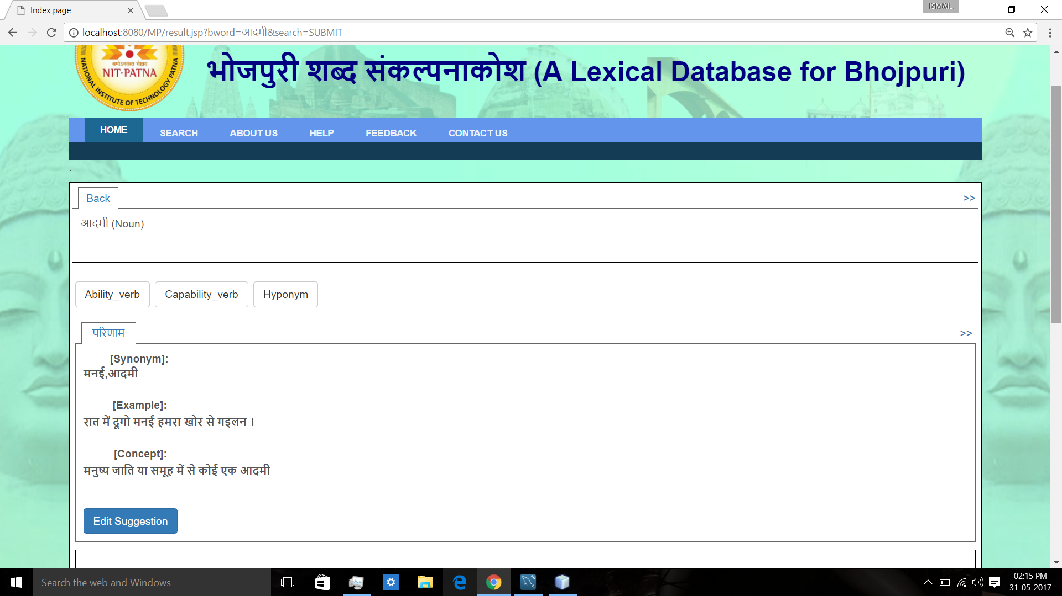

Figure 3. Synset in web page of Bhojpuri WordNet
5 Work in progress
RDF (Resource Dsescription Framework) for this Bhojpuri WordNet is being created and will be available on web portal for downloading. An attractive graph visualization is also under construction so that the synset details and its relations with other synsets will be represented more clearly in graph form. We are constructing an Android app also for representing the synset information.
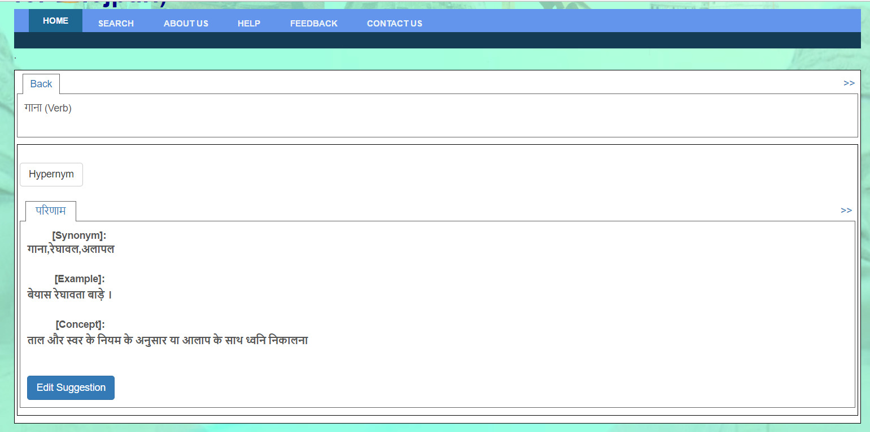

Figure 4. Capability_verb relation of ‘मनई’synset
6 Conclusion
Paper gives information about developing the Bhojpuri WordNet. It describes process of creating synsets from Hindi synset using expansion approach. Semantic and lexical relationships are defined between synset concepts and words respectively. Various relations like hypernym, hyponym, meronym, antonym, troponym, entailment etc are defined here and implemented between synsets of Bhojpuri language. Bhojpuri language is a language of Hindi family so some synsets of Bhojpuri contains some Hindi words which are used in Hindi and Bhojpuri also. For storing the data of Bhojpuri WordNet relational database form is used and accessed for various data with the help of synset_id given to each synset. Apart from having tables for storing words, concept, example and relationships one more table is used for storing the modifications or new words suggested by user publicly. That table’s data will be stored in final tables only after verifying its correctness.
References
1. S. Banerjee and T. Pedersen, \An adapted lesk algorithm for word sense disambiguation using WordNet," in International Conference on Intelligent Text Processing and Computational Linguistics. Springer, 2002, pp. 136-145.
2. A. Esuli and F. Sebastiani, \SentiWordNet: A high-coverage lexical resource for opinion mining," Evaluation, pp. 1-26, 2007.
3. C. Fellbaum, WordNet. Wiley Online Library, 1998.
4. C.-R. Huang, S.-K. Hsieh, J.-F. Hong, Y.-Z. Chen, I.-L. Su, Y.-X. Chen, and S.-W. Huang, Chinese WordNet: Design, implementation, and application of an infrastructure for cross-lingual knowledge processing," Journal of Chinese Information Processing, vol. 24, no. 2, pp. 14-23, 2010.
5. K. Knight and S. K. Luk, \Building a large-scale knowledge base for machine translation," in AAAI, vol. 94, 1994, pp. 773-778.
6. M. Maziarz, M. Piasecki, and S. Szpakowicz, \Approaching plWordNet 2.0," in Proceedings of 6th International Global WordNet Conference, The Global WordNet Association, 2012, pp. 189-196.
7. G. A. Miller, \WordNet: a lexical database for english," Communications of the ACM, vol. 38, no. 11, pp. 39-41, 1995.
8. A. Narang, R. Sharma, and P. Kumar, \Development of punjabi WordNet," CSI transactions on ICT, vol. 1, no. 4, pp. 349-354, 2013.
9. S. Scott and S. Matwin, \Text classi_cation using WordNet hypernyms," in Use of WordNet in natural language processing systems: Proceedings of the conference, 1998, pp. 38-44.
10. M. Sinha, M. Reddy, and P. Bhattacharyya, \An approach towards construction and application of multilingual indo-WordNet," in 3rd Global WordNet Conference (GWC 06), Jeju Island, Korea, 2006.
11. E. M. Voorhees, \Query expansion using lexical-semantic relations," in SIGIR94. Springer, 1994, pp. 61-69.
12] P. Vossen and C. Letteren, \EuroWordNet: a multilingual database for information retrieval," in Proceedings of the DELOS workshop on Cross-language Information Retrieval, 1997, pp. 5-7.

https://en.wikipedia.org/wiki/Bhojpuri_language

